1. **Explain the advantages of Natural Queries in PowerBi with an example?**

**Ans-**

* The Natural Queries is basically a language of Q&A feature in Power BI
* It allows you to type your question in the ‘**Ask a question about your data**’ box to quickly get answers from your data.
* Power BI looks for the best answers based on the dataset of your dashboard. Power BI picks the best visual to display your answer and has an inbuilt auto-complete feature and suggestions for your questions.
* These are the big advantage to get visual or data within one line of queries and save time and make it easier for other users,
* Power BI allows you to save frequently asked questions, so they are readily available for other users.
* **Process of Natural Queries:-**
  + You can activate the Q&A section
  + Add the various types of questions and also on the suggestion So that you will get various types of questions that you will find very useful.
  + **Example:-** **Total delivery day over time**, below show the visual about our natural queries.

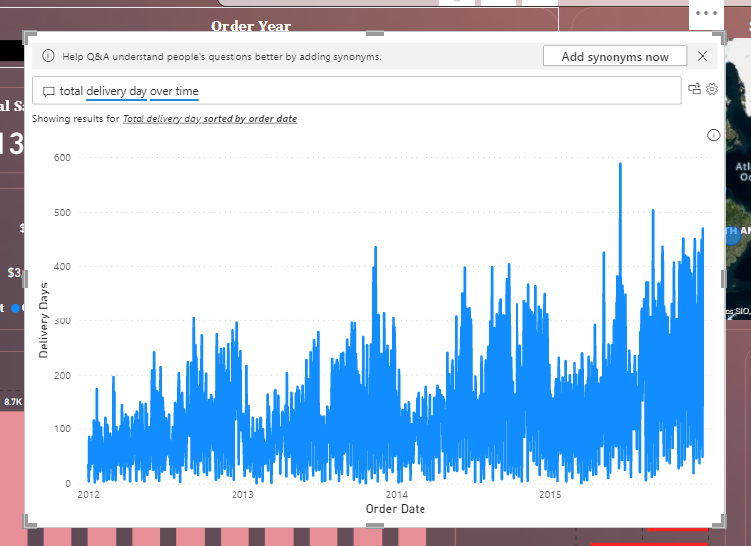

1. **Explain Web Front End(WFE) cluster from Power BI Service Architecture?**

**Ans-**

* Any report which is created on Power BI Desktop is to be published on a cloud platform known as Power BI Services.
* Users can access the reports and dashboards from Power BI Service using client platforms like websites, mobile devices, etc.
* Power BI Service’s architecture consists of two parts:
  + Front End Cluster
  + Back End Cluster
* **Front End Cluster**
  + The front end also called the **Web Front-End Cluster** acts as an intermediary between clients and the back end.
  + The front-end services are used for establishing an initial connection and authenticating clients using Azure Active Directory.

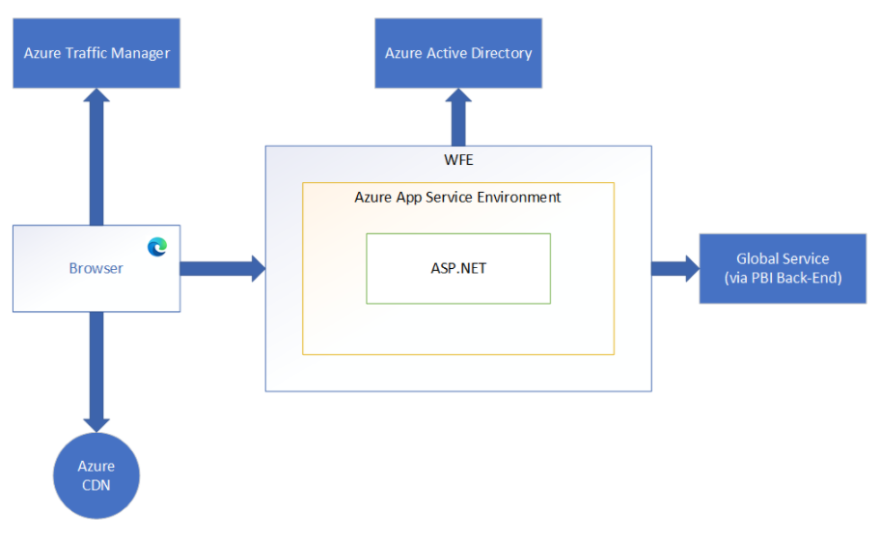

* + The Azure Active Directory stores user identities. Along with this, Azure Traffic Manager is used to direct user requests to the nearest data center after authentication. Once a client/user is authenticated, the Azure Content Delivery Network (CDN) distributes static Power BI content/files to users.

1. **Explain Back End cluster from Power BI Service Architecture?**

**Ans-**

* **Back End Cluster**
  + The Power BI services at the back end cluster also known as **Web Back-End Cluster,** take care of visualizations, datasets, storage, reports, data connections, data refreshing, and other interactions with Power BI.
  + At the back-end, a web client has only two direct points of interaction, Azure API Management, and Gateway Role.

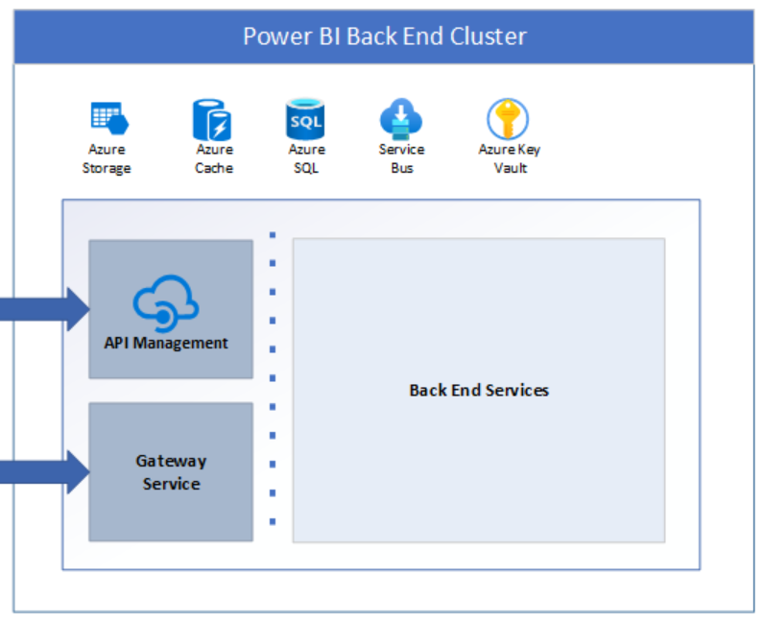

* + These two components are responsible for load balancing, authentication, authorization, routing, etc.

1. **What ASP.NET component does in Power BI Service Architecture?**

**Ans-**

* A WFE cluster consists of an ASP.NET website running in the Azure App Service Environment.
* The WFE cluster assigned to the user manages the login and authentication sequence (described later in this article) and obtains an Azure AD access token once authentication is successful
* The ASP.NET component within the WFE cluster parses the token to determine which organization the user belongs to and then consults the Power BI Global Service.

1. **Compare Microsoft Excel and PowerBi Desktop on the following features:**

**Ans-**

| **Features** | **Microsoft Excel** | **Power BI Desktop** |
| --- | --- | --- |
| **Data Import** | Excel can import data from external data sources including other files, databases, or web pages. Limited Source | Power Bi is an enormous no of data sources excepted direct or query both. |
| **Data Transformation** | Excel is used to organize data, transform it and performing mathematical operations and calculations | Power BI was conceived as a business intelligence and [data visualization](https://blog.bismart.com/en/data-visualization-with-power-bi) tool for businesses |
| **Modeling** | Excel is totally focused on structured and simple [data models](https://www.educba.com/data-models-in-dbms/) with a wide range of features. | Power BI is really focused on data ingest and building potentially complex data models easily. |
| **Reporting** | Reports available is limited to specific users. | Reports are available to a broad range of readers with varying degrees of tech-savvy. |
| **Server Deployment** | Excel needs additional functionality to deploy | Power BI copies the content from the current stage, into the target one |
| **Convert Model** | MDX | DAX |
| **Cost** | Payment tool | It has a free and paid version |

1. **List 20 data sources supported by Power Bi desktop.**

**Ans-**

1. SQL Server database
2. Access database
3. SQL Server Analysis Services database
4. Oracle database
5. IBM Db2 database
6. IBM Informix database (Beta)
7. IBM Netezza
8. MySQL database
9. PostgreSQL database
10. Sybase database
11. Teradata database
12. SAP HANA database
13. SAP Business Warehouse Application Server
14. SAP Business Warehouse Message Server
15. Amazon Redshift
16. Impala
17. Google BigQuery
18. Vertica
19. Snowflake
20. MariaDB